**SEC Data Acquisition**

This simple data acquisition for the SEC sensors reads two capacitance channels at 40Hz. Data is returned as tab delimitated rows over the serial port (USB) at a baud rate of 115200. The SEC’s are connected to the board through SMA connections. The shielding on the SMA connections is an active shielding that reduced the parasitic capacitance of the cables. The cable shielding is not tied to ground and care should be taken to isolate the shielding from ground. Each channel returns a 24 bit capacitance value,

* Channel 0 will read capacitance from 35pF to 65pF
* Channel 1 will read capacitance form 60pF to 90pF
* Channels 2 and 3 are disabled to enable faster acquisition rates.
* Capacitance ranges extend 1 pF past the listed ranges. This last pF is no specified in the capacitance to digital converter, may not be accurate and should not be used.

**SEC Hookup**

A basic SEC hookup is shown below. The activation cable is attached to the top plate of the SEC while the bottom plate is connected to the ground ports on the board.

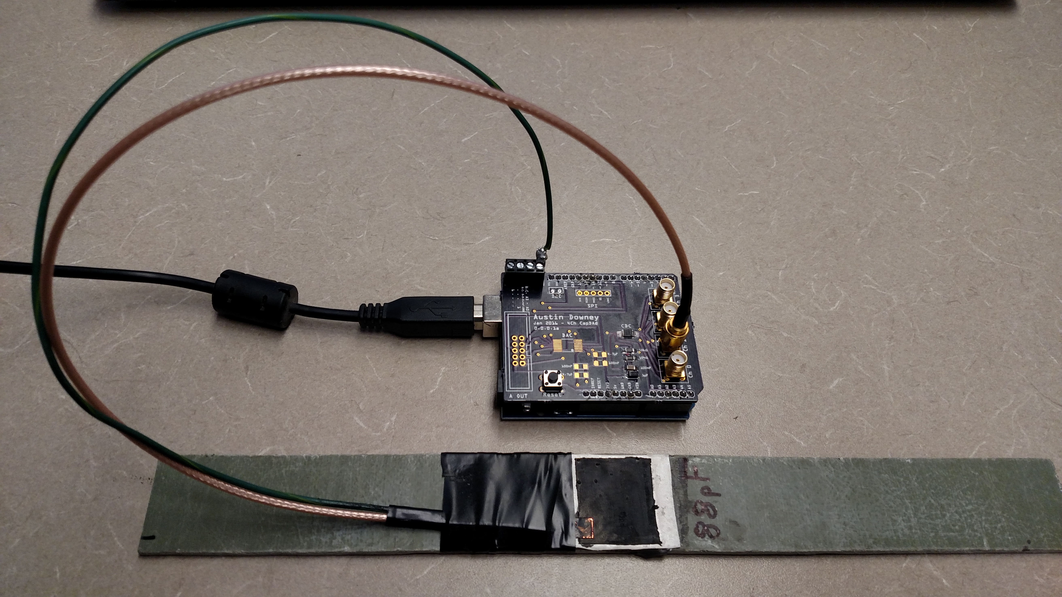

**Serial Data Acquisition**

Serial acquisition can be done a few ways.

* Coolterm can be downloaded from <http://freeware.the-meiers.org/>. This is a simple serial port emulator that will allow you to save serial data to a .txt file. While simple and reliable, this does not offer any real time data visualization.
* LabVIEW is an excellent option, but requires a LabVIEW licenses. I can share a LabVIEW code with you if needed. Just let me know what version you have.
* Matlab will let you read tab delimited serial port data, however I don’t have a working code for this particular setup.

**Noise**

The largest noise factor for this system seems to be caused by power quality and other items on the serial bus. To help and reduce this testing is best done with only one item on the USB. If needed power can be supplied to the DAQ using the included 9v battery connector. The figures below show the difference power quality can cause. These where taken on a static SEC, the figure on the left shows a sensor on mains power, and the figure on the right is the same sensor powered off a 9v battery.

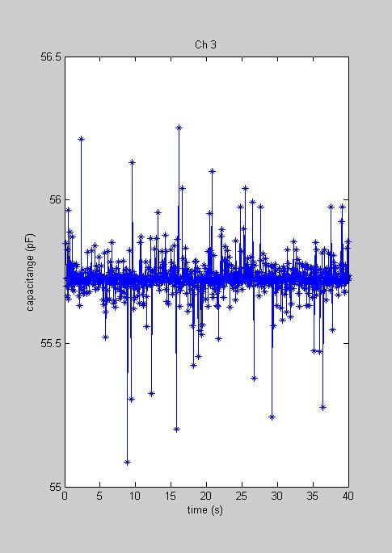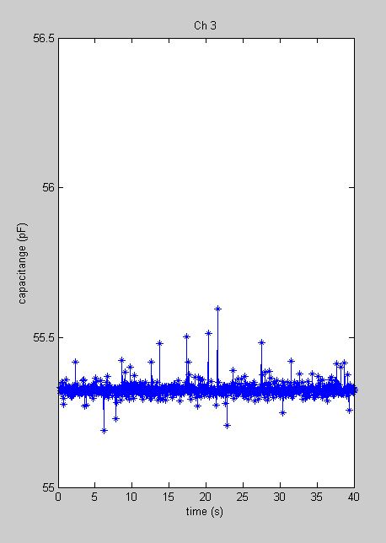

Below is a sample time series taken on this DAQ, this is approx. 2000 microstrain.

